Positive self-help flowers
LO: To know my good qualities

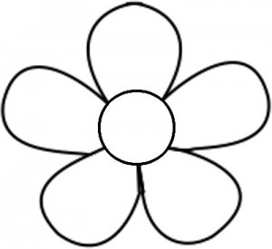

Thursday 9th of June 2016
Positive self-help flowers
LO: To know my good qualities

